Assignment 02
  - Deadline: Day 22/03/2017 @ 23:59
[Total Marks: 8/2 = 4]

Database management system
IT-344

Instructions:
- This Assignment must be submitted on Blackboard via the allocated folder.
- Email submission will not be accepted.
- You are advised to make your work clear and well-presented, marks may be reduced for poor presentation.
- You MUST show all your work.
- Late submission will result in ZERO marks being awarded.
- Identical copy from students or other resources will result in ZERO marks for all involved students.
- Convert this Assignment to PDF just before submission.
Student Details:
Name:Munirah alrushud  CRN:### |  | ID:140032004

Question One
2 Marks
Learning Outcome(s):

Consider the given query with multiple selection conditions; by taking into account the “Query Tuning”, please answer (a) and (b).

SELECT ESSN, LName, BDATE, Salary
FROM EMPLOYEE
WHERE Salary > 7500 OR ESSN < 205;

- Give a brief explanation of why the above query may not be prompting the query optimizer to use any index?

Answer:

Because of the (or) in the condition, it has more than condition and they are connected using the (or) and because of that the query may not be prompting the query optimizer to use index.

- Improve the above query in order to be able to use an index.

Answer:

Select *
From employee
Where salary > 7500 Union Select *
From employee
Where essn < 205;

Question Two
2 Marks
Learning Outcome(s):
Instructors: State the Learning Outcome(s) that match this question

Test the following schedule of three transactions for serializability. Also, describe that can we create its equivalent serial schedule. If yes then how else why?
S1: r2(A); r1(B); w2(A); r2(B); r3(A); w1(B); w3(A); w2(B)

Answer:

List S1 in order into the table:
T1 | T2 | T3
 | R2(A)
R1(B)
 | W2(A)
 | R2(B)
 |  | R3(A)
W1(B)
 |  | W3(A)
 | W2(B)

And then check if there are any conflicts between the transactions
We can note that there is a conflict between T2 T3
And another conflict in T1 T2
And a conflict in T2 T1
And a conflict in T1 T2

R+R(a) (Read & Read) will cause no conflicts between the transactions only (r&w) (w&r) (w&w)
So conflict will be:

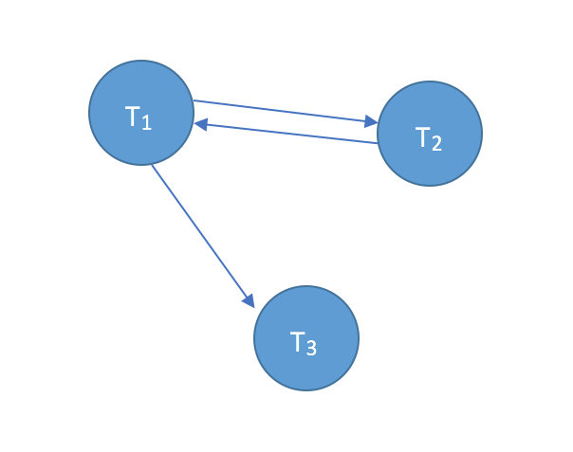
After graphing the dependency we’ll find out that there’s no serial schedule. So this is not a serializability.

Question Three
2 Marks
Learning Outcome(s):
Instructors: State the Learning Outcome(s) that match this question

Draw the state transition diagram and explain the states for transaction execution.

Answer:
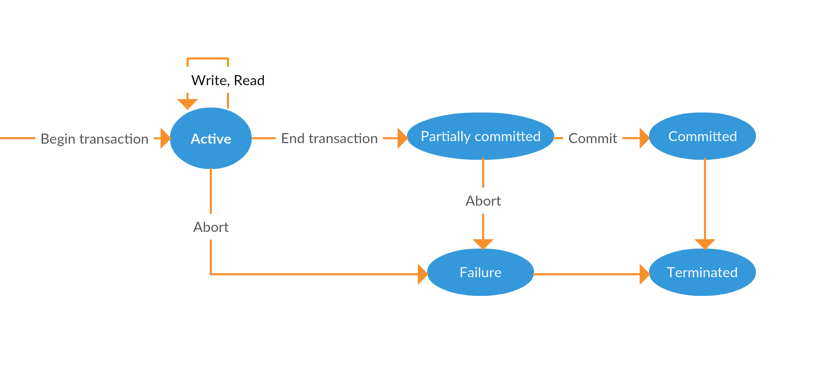
In transaction execution the circles mean state of the operation, and the arrows are the operation it self.
First thing to start transaction execution is to begin the transaction and then it will start reading and writing, reading and writing, … and the state here is active means the operation is working.
Ten after the read and write is done the transaction most be ended until the commit .. in this case the state will be partial committed until it been committed. Whenever the operation is committed it will terminate the operations successfully.
But in case the transaction has been abort in any state it’ll go to failure state and the terminated unsuccessfully.

Question Four
2 Marks
Learning Outcome(s):
Instructors: State the Learning Outcome(s) that match this question

Explain whether the following transactions T1 and T2 satisfy four variants of 2-Phase Locking protocol (2PL); Basic 2PL, Conservative 2PL, Strict 2PL, and Rigorous 2PL. Write "Yes" or "No", motivate your answers as why or why not and be specific.
T2
LOCK-S(A)
R(A)
LOCK-X(B)
UNLOCK(A)
R(B)
W(B)
COMMIT
UNLOCK(B)
T1
LOCK-S(A)
R(A)
LOCK-X(B)
R(A)
R(B)
B=A+B
UNLOCK(A)
W(B)
UNLOCK(B)

(here LOCK-S represents shared lock and LOCK-X represents exclusive lock).
Answer:

T1 | Basic 2PL | Yes / No:  [ Why / Why not ]  Yes, because the transactions satisfy Basic 2PL. Which means that there’s no UNLOCK in side LOCKs and no lock in side unlock operation. (growing phase and shrinking phase)
T1 | Conservative 2PL | Yes / No:  [ Why / Why not ]  No, because all the locks should be acquired before the transaction starts.
T1 | Strict 2PL | Yes / No:  [ Why / Why not ]  No, because there's no commit before the unlock B
T1 | Rigorous 2PL | Yes / No:  [ Why / Why not ]  If not strict then it's not rigorous ..

T2 | Basic 2PL | Yes / No:  [ Why / Why not ]  Yes, because the transactions satisfy Basic 2PL. Which means that there’s no UNLOCK in side LOCKs and no lock in side unlock operation. (growing phase and shrinking phase)
T2 | Conservative 2PL | Yes / No:  [ Why / Why not ]  No, because all the locks should be acquired before the transaction starts.
T2 | Strict 2PL | Yes / No:  [ Why / Why not ]  Yes, because the unlock of B is after the commit.
T2 | Rigorous 2PL | Yes / No:  [ Why / Why not ]  No, because all the looks should be unlocked after the commit. But here there's unlock A before the commit.

**************************END OF QUESTIONS************************

